**DEEP2NEURON TECH ACADEMY-INTERNSHIP 2023**

**DAY 1 -19.06.2023**

On the first day of my online internship, there was an interactive session about our college projects and our area of interest. The task was to select any project that uses CNN. I focused on picking an image processing project that uses convolutional neural networks (CNN).

**IMAGE PROCESSING**

Image processing provides a wide range of tools and techniques to analyze, modify, and extract information from digital images, enabling us to better understand and work with visual data and images. It refers to the manipulation and analysis of digital images using various techniques and algorithms.

**CONVOLUTIONAL NEURAL NETWORKS**

Convolutional Neural Networks specialized for applications in image & video recognition. CNN is mainly used in image analysis tasks like Image recognition, Object detection & Segmentation.

There are three types of layers in Convolutional Neural Networks:

1) **Convolutional Layer**: In a typical neural network each input neuron is connected to the next hidden layer. In CNN, only a small region of the input layer neurons connect to the neuron hidden layer.

2) **Pooling Layer**: The pooling layer is used to reduce the dimensionality of the feature map. There will be multiple activation & pooling layers inside the hidden layer of the CNN.

3) **Fully-Connected layer**: Fully Connected Layers form the last few layers in the network. The input to the fully connected layer is the output from the final Pooling or Convolutional Layer, which is flattened and then fed into the fully connected layer.

**PROJECT**

License Plate Recognition (LPR) is an automated system designed to capture, analyze and interpret license plate information from images. To address the challenges posed by manual license plate recognition, an automated LPR system can be developed using advanced technologies and algorithms. It can be achieved using Convolutional Neural Networks (CNNs) which are a type of deep learning algorithm specifically designed for image processing tasks. CNNs have proven to be highly effective in detecting and recognizing objects within images, making them suitable for license plate detection and character recognition. LPR system provides an efficient and effective solution to the manual process of license plate recognition enabling faster, more accurate and reliable results.

**REFERENCE**

<https://www.kaggle.com/code/sarthakvajpayee/license-plate-recognition-using-cnn>

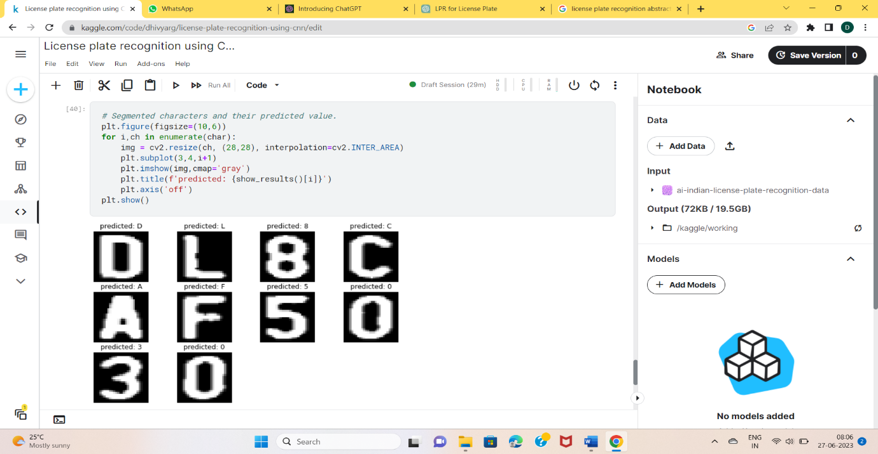

**OUTPUT**

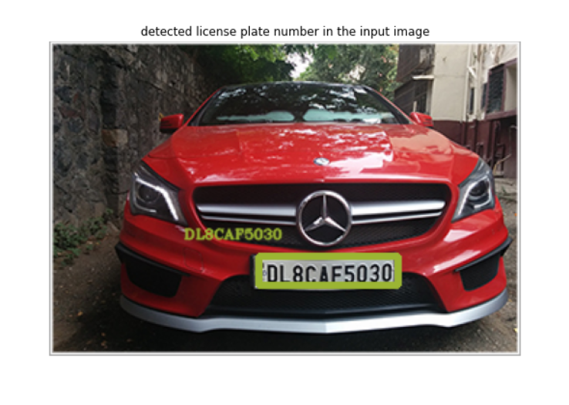

**TASKS COMPLETED**

* Created an account in GitHub and uploaded the Day -1 document in the repository in my account.
* Learnt some basics in CNN algorithm and developed a simple project.
* Found the way to build an abstract of the project.

**DOUBTS**

* No idea on how the algorithm works and where the model is trained.